20th Sunday after Pentecost

CHRIST LUTHERAN CHURCH | Lodi, California
October 15, 2023

WELCOME TO WORSHIP
Welcome to Christ Lutheran Church. We pray that your soul will be strengthened by the good news about God’s grace, love, and forgiveness given to us. If you would like to learn more about our church, please speak with our pastor or one of our members after the service.
- Bathrooms are located in the fellowship hall. A changing table is located in the women’s bathroom.
WORSHIP THEME
What makes the Christian joyful? This week, we continue looking at 4 readings from the book of Philippians. As we consider this chapter in God’s Word, we hear Paul speak about his joy again and again. But as we examine the circumstances of his life, we find that his joy comes from a deeper place than mere outward circumstance.
We press on toward our goal. We are not passively waiting for the joys of heaven; instead, overflowing with joy because of God’s grace to us, we actively seek to obey our God and produce fruits of faith. We recognize that we do not live up to the rich inheritance God has given, but we strive to take hold of that for which Christ has taken hold of us.
The Service of the Word and Sacrament
The high and holy worship of God is faith in Jesus Christ. Such faith is created and sustained by God’s service to us (the German, “Gottesdienst,” “God/Divine Service).
In the Divine Service, the Lord comes to us in His Word and Sacrament to bless and enliven us with His gifts. The Service is not something we do for God, but His service to us received in faith. The liturgy is God’s work. He gives, we receive.
HYMN Lord, Keep Us Steadfast in Your Word| CW 203

INVOCATION
From God’s Word we know that wherever God puts His name, there He is to bless. In the Old Testament the temple was the place where God graciously caused His name to be present (1 Kings 8:27-30).
God has put His name —Father, Son, and Holy Spirit—on us in Holy Baptism. The Divine Service begins with the Invocation, the words spoken over us at our baptisms. Every Divine Service is for the hallowing of the Lord’s name, which the Small Catechism reminds us is done “when the Word of God is taught in its truth and purity, and we, as the children of God, also lead holy lives according to it” (Matthew 28:18-20).
M: The grace of our Lord ✙ Jesus Christ and the love of God and the fellowship of the Holy Spirit be with you.
C: And also with you.
CONFESSION
M: God invites us to come into his presence and worship him with humble and penitent hearts. Therefore, let us acknowledge our sinfulness and ask him to forgive us.
C: Holy and merciful Father, I confess that I am by nature sinful, and that I have disobeyed you in my thoughts, words, and actions. I have done what is evil and failed to do what is good. For this I deserve your punishment both now and in eternity. But I am truly sorry for my sins, and trusting in my Savior Jesus Christ, I pray: Lord, have mercy on me, a sinner.

absolution
M: God, our heavenly Father, has been merciful to us and has given his only Son to be the atoning sacrifice for our sins. Therefore, as a called servant of Christ and by his authority, I forgive you all your sins in the name of the Father and of the Son ✙ and of the Holy Spirit.
C: Amen
LORD, HAVE MERCY - Kyrie
M: For all that we need in life and for the wisdom to use all your gifts with gratitude and joy, hear our prayer, O Lord.
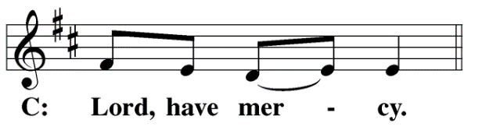
M: For the steadfast assurance that nothing can separate us from your love and for the courage to stand firm against the assaults of Satan and every evil, hear our prayer, O Christ.
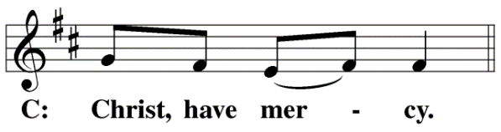
M: For the well-being of your holy Church in all the world and for those who offer here their worship and praise, hear our prayer, O Lord.
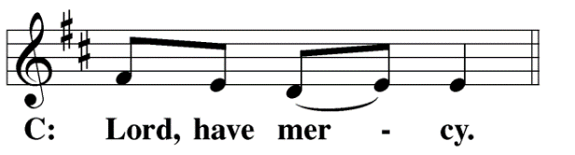
M: Merciful God, maker and preserver of life, uphold us by your power and keep us in your tender care:
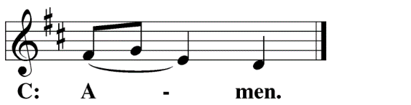
M: The works of the Lord are great and glorious; his name is worthy of praise.
O LORD, OUR LORD
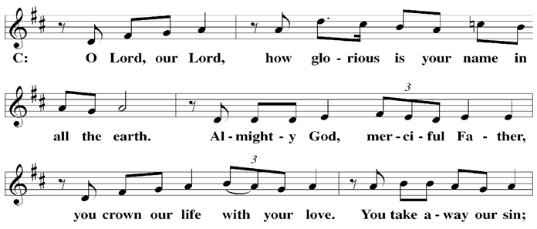

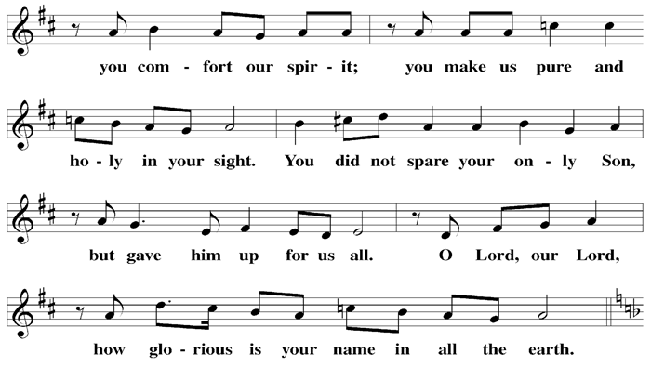

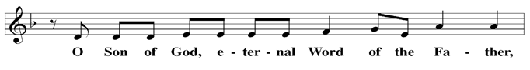

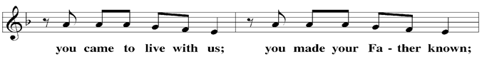

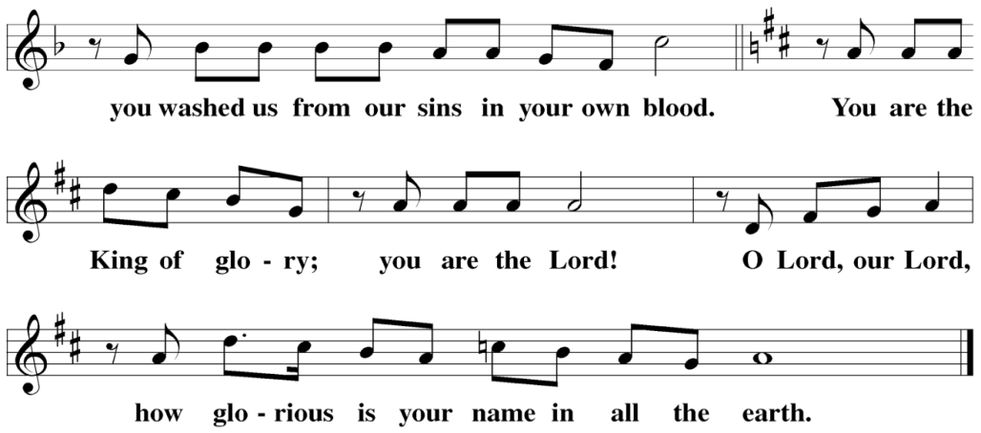

The Service of the Word
Having just received absolution for their sins, believers now gather around the Word of God to find encouragement and peace for their lives on earth.
PRAYER OF THE DAY
M: Let us pray.
Almighty God, in your bountiful goodness keep us safe from every evil of body and soul. Make us ready, with cheerful hearts, to do whatever pleases you; through Jesus Christ, your Son, our Lord, who lives and reigns with you and the Holy Spirit, one God, now and forever.
C: Amen
FIRST LESSON Isaiah 5:1–7
The Lord looked for fruit from his vineyard, Israel. When they didn’t produce it, he threatened his righteous judgment.
5 I will sing for the one I love
a song about his vineyard:
My loved one had a vineyard
on a fertile hillside.
² He dug it up and cleared it of stones
and planted it with the choicest vines.
He built a watchtower in it
and cut out a winepress as well.
Then he looked for a crop of good grapes,
but it yielded only bad fruit.
³ “Now you dwellers in Jerusalem and people of Judah,
judge between me and my vineyard.
⁴ What more could have been done for my vineyard
than I have done for it?
When I looked for good grapes,
why did it yield only bad?
⁵ Now I will tell you
what I am going to do to my vineyard:
I will take away its hedge,
and it will be destroyed;
I will break down its wall,
and it will be trampled.
⁶ I will make it a wasteland,
neither pruned nor cultivated,
and briers and thorns will grow there.
I will command the clouds
not to rain on it.”
⁷ The vineyard of the Lord Almighty
is the nation of Israel,
and the people of Judah
are the vines he delighted in.
And he looked for justice, but saw bloodshed;
for righteousness, but heard cries of distress.
PSALM Psalm 118, pg 108
SECOND LESSON Philippians 3:12–4:1
Christ has taken hold of you. Your future with your Savior is secure. How, then, will we live?
¹² Not that I have already obtained all this, or have already arrived at my goal, but I press on to take hold of that for which Christ Jesus took hold of me. ¹³ Brothers and sisters, I do not consider myself yet to have taken hold of it. But one thing I do: Forgetting what is behind and straining toward what is ahead, ¹⁴ I press on toward the goal to win the prize for which God has called me heavenward in Christ Jesus.
¹⁵ All of us, then, who are mature should take such a view of things. And if on some point you think differently, that too God will make clear to you. ¹⁶ Only let us live up to what we have already attained.
¹⁷ Join together in following my example, brothers and sisters, and just as you have us as a model, keep your eyes on those who live as we do. ¹⁸ For, as I have often told you before and now tell you again even with tears, many live as enemies of the cross of Christ. ¹⁹ Their destiny is destruction, their god is their stomach, and their glory is in their shame. Their mind is set on earthly things. ²⁰ But our citizenship is in heaven. And we eagerly await a Savior from there, the Lord Jesus Christ, ²¹ who, by the power that enables him to bring everything under his control, will transform our lowly bodies so that they will be like his glorious body.
4 Therefore, my brothers and sisters, you whom I love and long for, my joy and crown, stand firm in the Lord in this way, dear friends!
VERSE OF THE DAY Hebrews 2:12
Alleluia. I will proclaim your name to my people; in the midst of the congregation I will praise you. Alleluia.
THE GOSPEL Matthew 21:33–43
God patiently waited for fruits of faith and righteousness from the people of Israel. But the Pharisees were more interested in their own personal gain. Jesus reminds us that the kingdom is ours by grace—and that grace will produce fruit.
³³ “Listen to another parable: There was a landowner who planted a vineyard. He put a wall around it, dug a winepress in it and built a watchtower. Then he rented the vineyard to some farmers and moved to another place. ³⁴ When the harvest time approached, he sent his servants to the tenants to collect his fruit.
³⁵ “The tenants seized his servants; they beat one, killed another, and stoned a third. ³⁶ Then he sent other servants to them, more than the first time, and the tenants treated them the same way. ³⁷ Last of all, he sent his son to them. ‘They will respect my son,’ he said.
³⁸ “But when the tenants saw the son, they said to each other, ‘This is the heir. Come, let’s kill him and take his inheritance.’ ³⁹ So they took him and threw him out of the vineyard and killed him.
⁴⁰ “Therefore, when the owner of the vineyard comes, what will he do to those tenants?”
⁴¹ “He will bring those wretches to a wretched end,” they replied, “and he will rent the vineyard to other tenants, who will give him his share of the crop at harvest time.”
⁴² Jesus said to them, “Have you never read in the Scriptures:
“‘The stone the builders rejected
has become the cornerstone;
the Lord has done this,
and it is marvelous in our eyes’?
⁴³ “Therefore I tell you that the kingdom of God will be taken away from you and given to a people who will produce its fruit.

M This is the Gospel of the Lord.
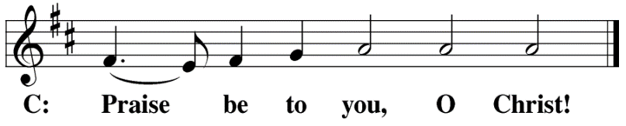

HYMN OF THE DAY My Song is Love Unknown| CW 110
SERMON Philippians 3&4
NICENE CREED
Having heard the Word of God, we confess our faith in His name. The creed is our saying back to God what He has first said to us. In the Creed we acclaim the truth of the triune God and His work of salvation accomplished for us in His incarnate Son, Jesus Christ.
We believe in one God, Dt. 6:4
the Father, the Almighty, 2 Cor. 6:18
maker of heaven and earth, Is. 51:13
The Nicene Creed is the great Confession of the Christian faith professed by all Christians. The Creed originated at the First Council of Nicaea (c. AD. 325)
of all that is, seen and unseen. Col. 1:16
We believe in one Lord, Jesus Christ, 1 Cor 8:6
the only Son of God, Jn. 3:16
eternally begotten of the Father, Heb. 1:2,5
God from God, Light from Light, true God from true God, Jn. 1
begotten, not made, of one being with the Father. Jn. 10:30
Through him all things were made. Jn. 1:3
For us and for our salvation, 1 Th. 5:9
he came down from heaven, Jn. 6:38
was incarnate of the Holy Spirit and the virgin Mary, Lk. 1:35
The Creed itself was crafted as a confession of Scripture in opposition to the Arian heresy, which denied that the Lord Jesus and the Holy Spirit are God.

and became fully human. Gal. 4:4
For our sake he was crucified under Pontius Pilate. Mk. 15:15
He suffered death and was buried. 1 Cor. 15:3-4a
On the third day he rose again in accordance
with the Scriptures. 1 Cor. 15:4b
He ascended into heaven Ac. 2:33-34
and is seated at the right hand of the Father. Heb. 1:13
He will come again in glory Mt. 25:31
to judge the living and the dead, 2 Tim. 4:1
and his kingdom will have no end. Lk. 1:33

We believe in the Holy Spirit, the Lord, the giver of life, Job 33:4
who proceeds from the Father and the Son, Jn. 15:26
who in unity with the Father and the Son Jn. 4:24
is worshiped and glorified,
who has spoken through the prophets. 2 Pet. 1:25
We believe in one holy Christian Mt. 16:18; Eph. 2:19-20
and apostolic Church.
We acknowledge one baptism for the forgiveness of sins. Eph. 4:5; Ac. 2:38
We look for the resurrection of the dead 1 Cor. 15:21-22
and the life of the world to come. Amen. Rev. 22
OFFERING
In response to God’s love and forgiveness, we give back a portion of what he has given us. The members of Christ Lutheran Church have joined to proclaim the gospel to this community. These offerings support that work. While our guests are welcome to participate, they should not feel obligated to do so.
PRAYER OF THE CHURCH
M: Lord God, Heavenly Father, you have planted us in your world and now call us to produce fruit. You have given us your Word and Sacraments to sustain us and make us flourish. We now come before you and ask for your mercy:
Upon our nation; bestow your grace. Grant us leaders who are wise and capable in a time of uncertainty. May our elected officials be dedicated to justice and the good of all. May we set aside petty divisions and seek unity in our land.
C: We thank you for your grace, and we ask for your mercy.
M: Upon our world; send your peace through the lives of your servants. Make missionaries, pastors, and lay people everywhere salt and light in this world. Where tragedies strike, where wars rage, and where the burdens of sin and imperfection weigh on people’s spirits; in every circumstance, send your gospel to restore hope. Bless those who serve in useful vocations: doctors and nurses, emergency responders, soldiers, counselors, teachers, parents and all those whose lives and work bless others with security and stability.
In this time of war, we ask that you will move this world toward peace. We wait with patience and trust that even in times of evil, you will accomplish good: the sparing of innocent lives and the salvation of souls.
C: We hold up our hands in prayer for all those affected by sin. We ask for your mercy.
M: Upon our church; through humble means you have chosen to reveal yourself: in the human body of our Lord on the cross; in the spoken word echoing through history and resounding in our ears; in a splash of water and the taste of bread and wine; through these means of grace, you have given us your promises and convinced us of your love.
Though we may be small, your promises are not. May we hold out your humble means of grace, and with them your powerful arm to save. May we be bold to share your truth, compassionate to the weary and oppressed, and faithful in all our work. If it is your will, draw more into your flock that is among us, that we may continue to share your truth with generations to come.
C: Grant us these things, Father, for your Son’s sake. In His name we join to pray:
LORD’S PRAYER Matthew 6:9-13; Luke 11:2-4
C: Our Father, who art in heaven, hallowed be thy name,
thy kingdom come, thy will be done on earth
as it is in heaven.
Give us this day our daily bread; and forgive us our trespasses,
as we forgive those who trespass against us;
and lead us not into temptation, but deliver us from evil.
For thine is the kingdom and the power
and the glory forever and ever. Amen.
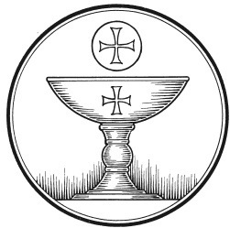
The Service of the Sacrament
This greeting marks a new service, so to speak. These ancient introductory words & phrases help to highlight, celebrate and bring attention to the Sacrament.
M: The Lord be with you.
C: And also with you.
M: Lift up your hearts.
C: We lift them up to the Lord.
M: Let us give thanks to the Lord our God.
C: It is right to give him thanks and praise.

M: Praise to the God and Father of our Lord Jesus Christ! In love he has blessed us with every spiritual blessing. He sends the Holy Spirit to testify that we are his children and to strengthen us when we are weak. Now have come the salvation and the power and the kingdom of our God and the authority of his Christ. To him who sits on the throne and to the Lamb be praise and thanks and honor and glory for ever and ever:

HOLY, HOLY, HOLY – Sanctus
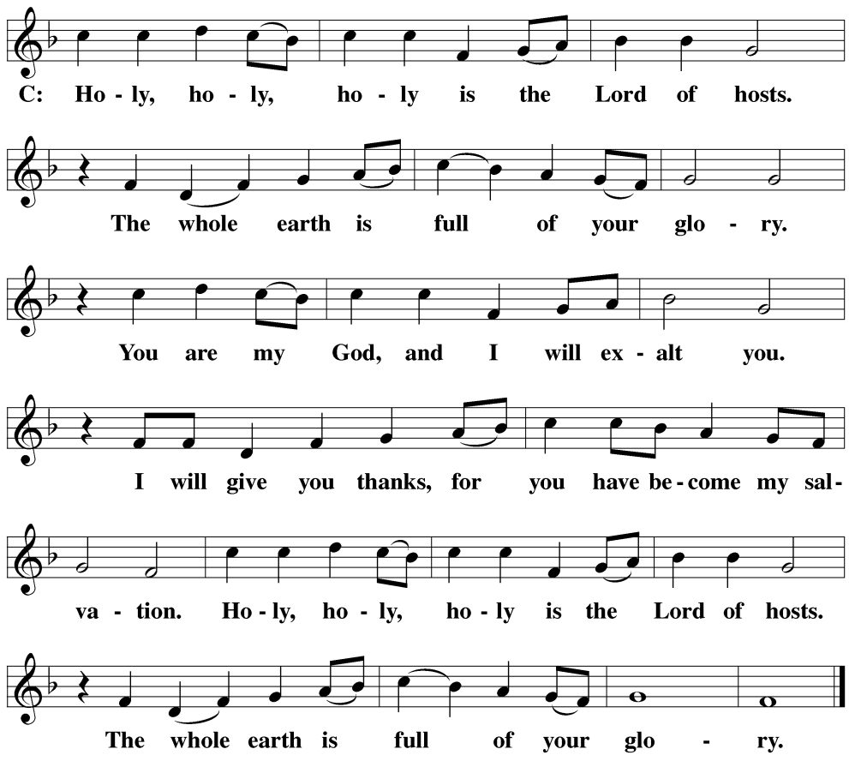

WORDS OF INSTITUTION Matthew 26, Mark 14, Luke 22
M: Our Lord Jesus Christ, on the night he was betrayed, took bread; and when he had given thanks, he broke it and gave it to his disciples, saying: “Take and eat. This is my ✙ body, which is given for you. Do this in remembrance of me.”
The Words of institution both proclaim the words of Jesus to the congregation and sets apart the bread and wine for the Lord’s Supper.
Then he took the cup, gave thanks, and gave it to them, saying, “Drink from it all of you; this is my ✙ blood of the new covenant, which is poured out for you for the forgiveness of sins. Do this, whenever you drink it, in remembrance of me.”
PEACE OF THE LORD – Pax Domini John 20:19
M: The peace of the Lord be with you always.
C: Amen
O CHRIST, LAMB OF GOD – Agnus Dei John 1:29
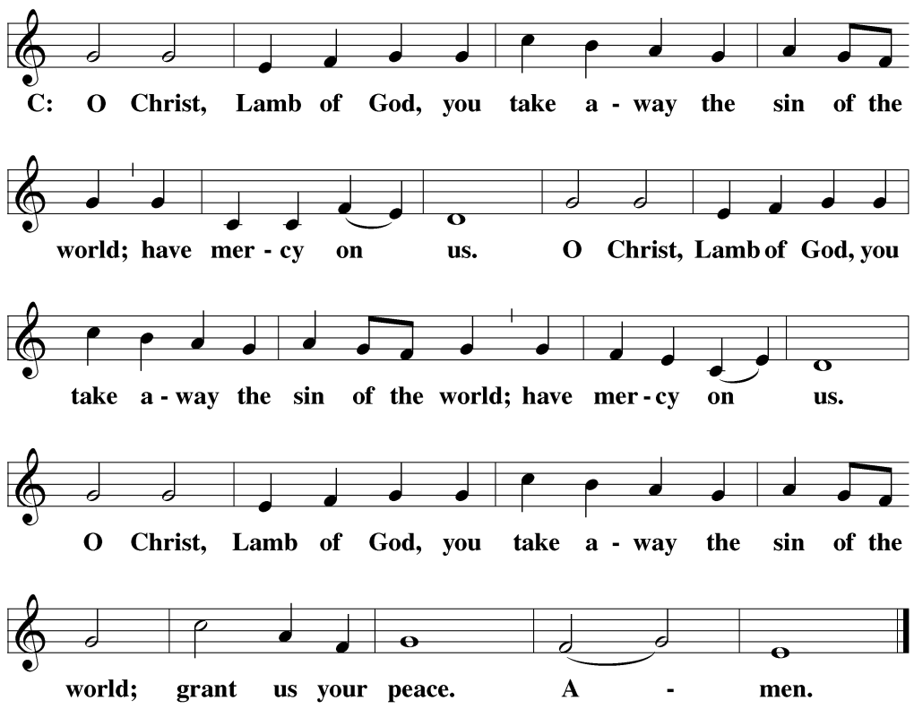

DISTRIBUTION
Those who will be receiving Holy Communion today may wish to read Personal Preparation for Holy Communion, found on page 156 in the front section of the hymnal. This page helps us put into practice what the Bible encourages: “Everyone ought to examine themselves before they eat of the bread and drink from the cup.” (1 Corinthians 11:28)
Christ Lutheran Church confesses and practices the Biblical teaching of a Closed Communion. We ask that only members of the Wisconsin Synod [WELS] or the Evangelical Lutheran Synod [ELS] join us at the Lord’s Table. If you have questions concerning our communion practice, or would like to inquire about how you, too, can commune with us, please speak with the Pastor following the service.

THANK THE LORD
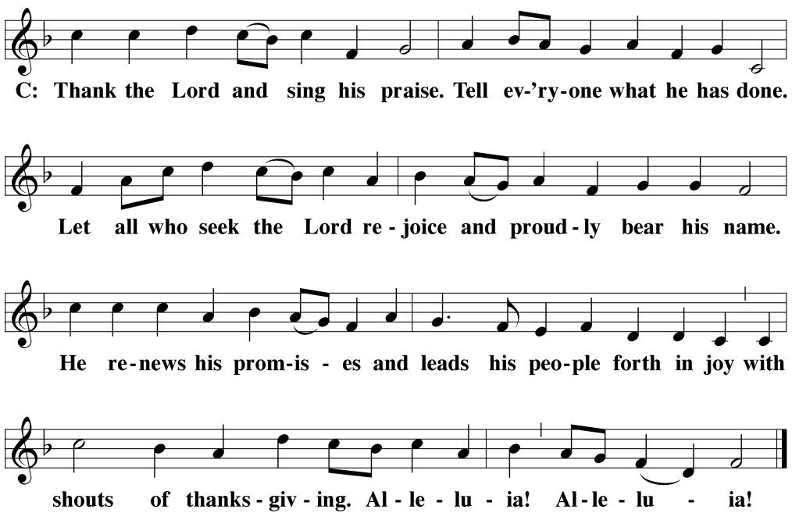
M: Hear the prayer of your people, O Lord, that the lips which have praised you here may glorify you in the world, that the eyes which have seen the coming of your Son may long for his coming again, and that all who have received in his true body and blood the pledge of your forgiveness may be restored to live a new and holy life, through Jesus Christ, our Lord, who lives and reigns with you and the Holy Spirit, one God, now and forever.
C: Amen.
THE BLESSING
M: Brothers and sisters, go in peace. Live in harmony with one another. Serve the Lord with gladness.
The Lord bless you and keep you.
The Lord make his face shine on you and be gracious to you.
The Lord look on you with favor and ✙ give you peace.
C: Amen.
CLOSING HYMN All I Have Is Christ | CW ’21 580

COPYRIGHT INFORMATION
Content requiring a copyright license is reproduced under OneLicense.net #A-718312. All rights reserved. The Common Service: Texts revised from The Lutheran Hymnal, 1941. Music revised by James Engel. Scripture Quotations: From the Holy Bible, New International Version (NIV 1984), © 1973, 1978, 1984 by Biblica, Inc.

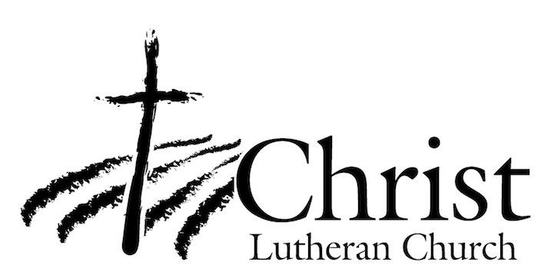
13009 N. Elderberry Ct.
Lodi, CA 95242
www.christlodi.org
209-368-6250
Pastor Tim Leistekow
WELCOME TO CHRIST EV. LUTHERAN CHURCH!
We preach a message of forgiveness, hope and peace
through the death and resurrection of Jesus Christ.
Families and individuals of all ages will find opportunities
both to grow and to serve.
Our mission statement:
Look what Christ is doing!
He binds us together in fellowship
He gathers us in for worship
He builds us up for service
He sends us out with the gospel

“Now you are the body of Christ,
and each one of you is a part of it.”
(1 Corinthians 12:27)

